Contents
SCHMI’s E-Appointment System (English) 2
Login Page 2
Home Page 2
How to register an account? 3
中华医院网上预约系统 (中文) 5
登录界面 5
主界面 5
怎么注册一个账号? 6

SCHMI’s E-Appointment System (English)
Login Page | Home Page
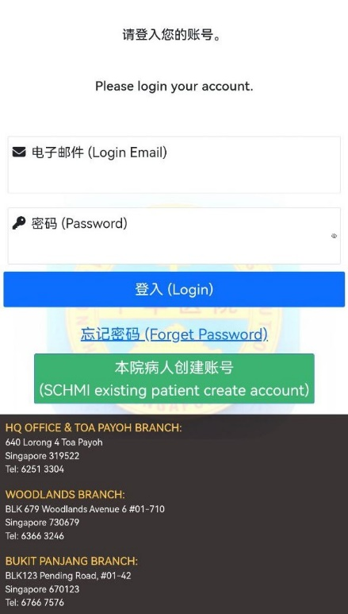 | 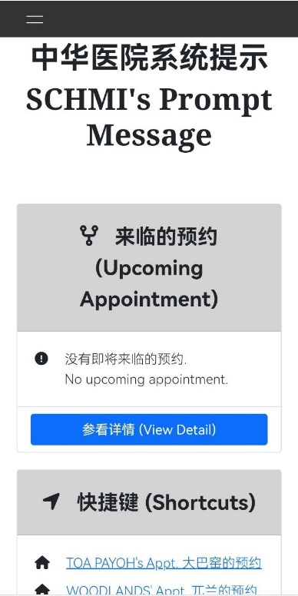

How to register an account?
- Register an account ONLY for our existing patients
- Please click the “本院病人创建账号 (SCHMI existing patient create account)” to verify patient’s basic info which register in SCHMI, as below:
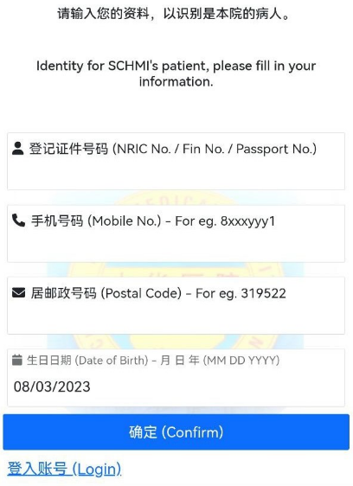
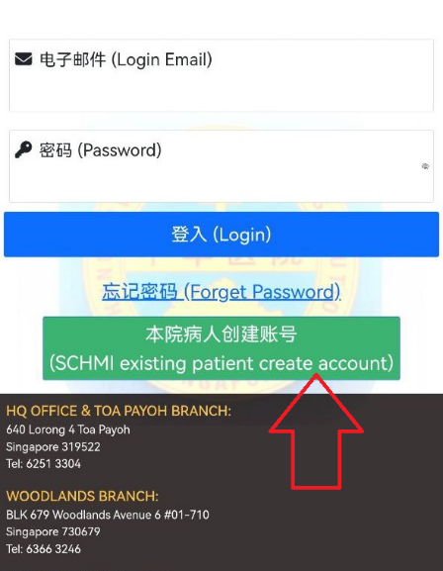

- The information below must make sure all correct
  - NRIC No. / Fin No. / Passport No.
  - Mobile No.
  - Postal Code
  - Date of Birth

- If you get the error message below, please call our hotline 62513304 to cross check:
It might be you changed the phone number / moved to a new place, our side don’t have the latest update from you.
Or our staff typo for your information.
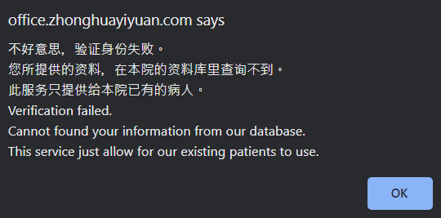

- You will get the message below if your information is correct.
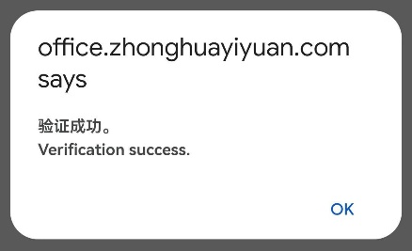
- Please enter your email address and password to create an account.
Email address must be unique.
Password strength must be at least medium level.
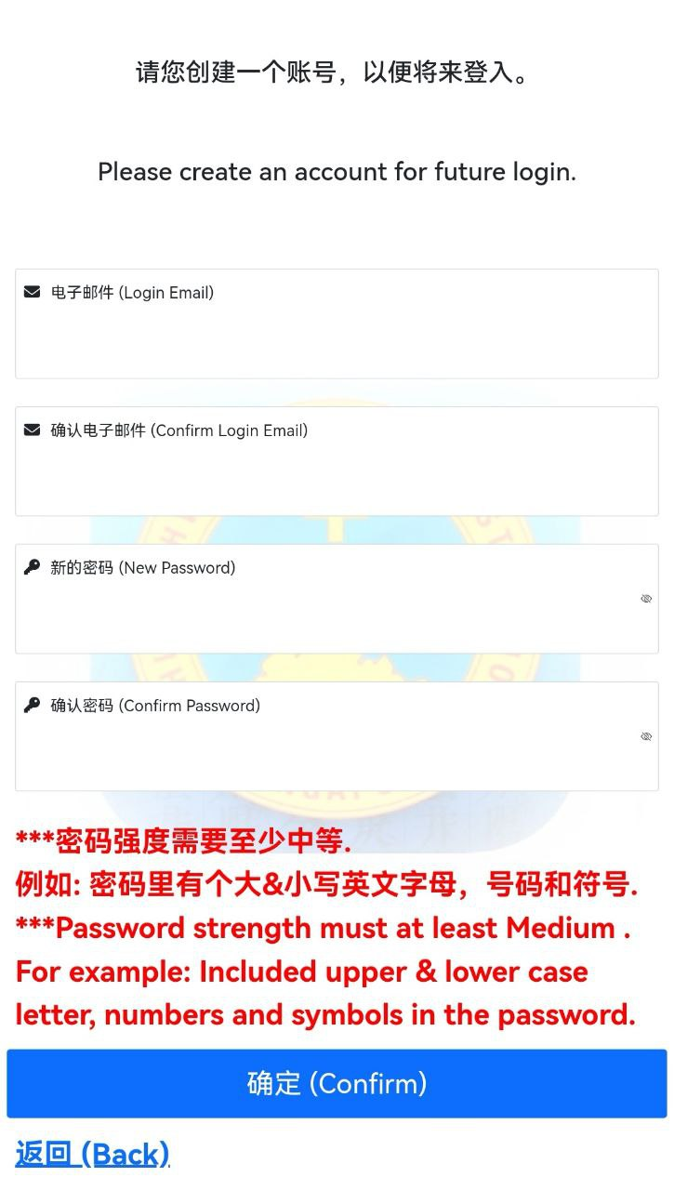

- You will get the message below when you created the account. Then it will autologin to our home page.
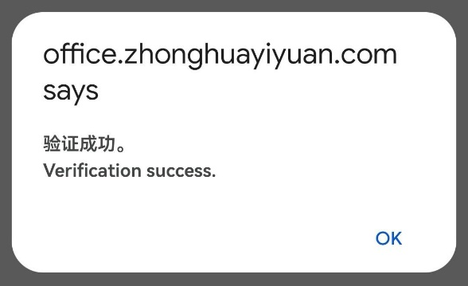

- So, you can log in by key in your email address and password in future.

中华医院网上预约系统 (中文)
登录界面 | 主界面

怎么注册一个账号?
- 注册账号只开放给本院的病人
- 请点击 “本院病人创建账号 (SCHMI existing patient create account)” 以验证您的个人资料，如图下所指的按钮:

- 所有个人资料都必须正确
  - 登记号 / 准证号 / 护照号码.
  - 手机号码
  - 居邮政号码
  - 生日日期

- 如果以下的信息弹出来, 请致电到我们的热线62513304:
失败的原因有可能是因为您换了手机号或是迁居新住宅, 我们没有您的资料更新.
又或者是因为我们的工作人员输入错误您的个人资料.

- 如果您的个人资料都正确，您将会看到以下的信息弹出.

- 请输入您的电子邮件还有新的密码
电子邮件必须是独特唯一的.
密码强度必须至少中等等级.

- 账号注册成功，您将看到以下信息. 然后将会自动登入到我们的主界面.

- 所以下次登入的时候，您可以在我们的登入界面输入您的电子邮件还有密码登入本院的预约系统.

